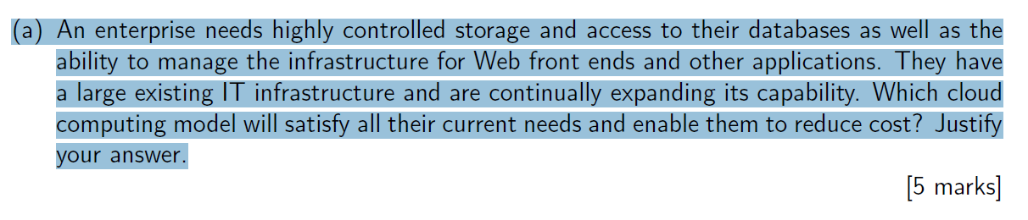

Hybrid cloud. They have their own infrastructure, manage their own infrastructure. And they would need extra resources occasionally.

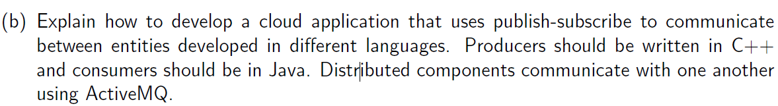

ActiveMQ will by default provide you inter-operability. The language that producers and consumers use are not revelant. Because as a consumer you will have to create connection, you have to set up a session you need to know who you are communicating with. The producer will do exactly the same thing, create connection, you will have to set up a session. You will get the released ? resources that would be consumers. And finally start sending and receiving messenges.

The answer is inter-operability issue. And non relevance of the programming language. And what this ?? consumer and produces are actually use.

You have 2 ways to get the notifications about the ?? avialiability of the messages. The consumer for example can set what they called handler, which is very much a sort of proxy. Once a message is copied into the queue in the consumer gets automatic notification. Or alternatively, the consumer can simply put the message in the queue, simply check the queue if there are any incoming messages. There are bascially two ways to do it.

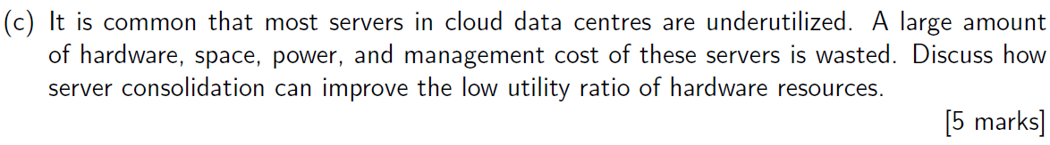

Monitor cloud usage and load.

When the load decreases, we need to live migrate VMs to more utilized nodes. And shut down unused nodes.

When the load increase, we need to start up waiting nodes and schedule new VMs to new nodes.

---------------------------------------------------------

With server, consolidation, you need to limit or reused the number of servers currently in use in your cloud data infrastructure. You do this, through what we call a virtualized based service consolidation. But your servers, at the end of the day, are running virtual machines. So if you move a number of virtual machines to existing running on it on some servers to run on other servers. You can then switch off some other servers. Therefore, reducing the actual cost inherent in your in managing your cloud data infrastructure. So the improvement is you have less server running, you have less cost or infrastructure to manage.

The question is to explain that consolidation is a virtualized based. It’s about VM running on those servers and then allocate your VM to different servers, so that you can switch off some of your servers and by switching off some of your servers, you have an impact on the cost.

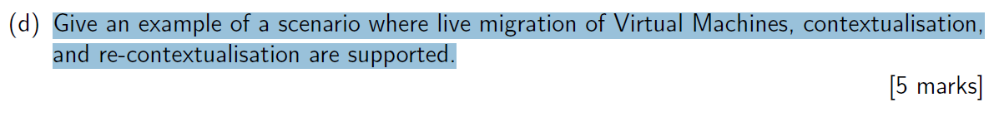

A distributed file system. It can be autonomously configuring and deployment to a specific environment. And it’s performance can be degraded due to previous settings. So it need to be live migration to another node. And it’s data also can be exchanged with a remote server node without shunting down the VM.

The lecture on middleware, contextualisation, expected to see automatic configuration. Automatic configuration of libraries in terms of software needed, networking like IP addresses, mac addresses, etc. All this is supposed to be done transparently and automatically. It’s hidden to you as the user of the virtual machine.

With recontextualisation, we take the sernario where the VM has been set up and running in a cloud environment. ?? Then the machine is going to run in a completed different cloud environment. For example, a different service provider. Because of the differences in how differences the cloud infrastructure is set up. What will happen is you need to recontextualize on the file. So you would take all VM and ensure ?? in running.

Recontextualisation means obviously, an automatic configuartion on the file ?? on that VM. The recontextualisation will take the information avaliable regarding the contextualization phase, and somehow update that information so that your VM is able to run on different cloud environment.

In this scenario, you have a contextualisation is easy, you instantiate have a number of population of your virtual machine in terms of libraries operating systems, networking IP address, MAC address, etc.

In recontextualization, you take a virtual machine that is currently running on a cloud infrastructure. Then you decided to move that VM to run on another infrastructure. It’s like you have a VM on Amazon, then migrate to your own cloud. And that VM is running, you don’t want to stop it. Recontextualization means that you need to contextualise that VM…??? You take the contextualization information, and you will need to update that information so that your virtual machine will keep running in the new cloud infrastructure.

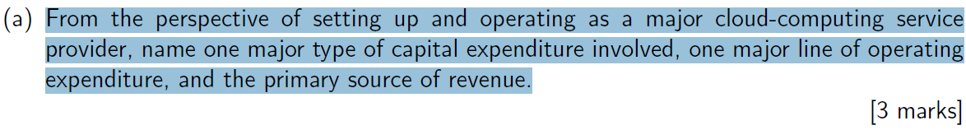

This have much the lecture at the beginning of the semester when we talked about cloud providers have to set up their cloud data center, because you have to think about an investment. And the second lecture is to do with the economy in relation to running a cloud infrastructure.

So the question about the capital expenditure. If you are Google, and you want new data center, where you have to think about the building, what we call as real estate. You will need to buy machines, these are your servers in thousands. You need to set up the network, and cooling system, etc. You need to invest money in relation to building your data centre.

When it’s comes to the operating expenditure, you have to think about your placing in place. What are the other costs that are inherent in running your cloud datacenter, and the example of this are a lot of them.

The first one is the electricity cost, you’d have to keep running your cloud data center and you’ll receive because we still keep consuming electricity. If you are providing services you are certainly running software and even the software that you run will have a licence associated with it. Itself is seen as an operating expenditure.

Server which shelf with the racks, the racks can come as the capital expenditure so these racks have to be boots. As part of your captial you need to buy servers and need to buy for those servers.

When it comes to server containers, are very much software that runs on a physical server. So containers are seen as running software costs.

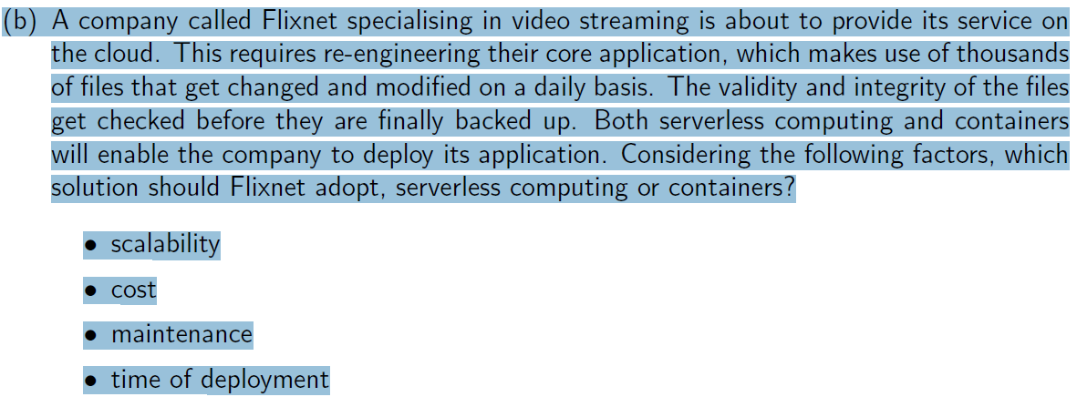

This question is very much about taking serverless architectures. Taking containers and comparing them in terms of four different criteria.

The number of containers that I will need to run it applications. Should be known in advanced. Clarify you need this number of containers to run. Everytime my system scales, I will need to re-estimate the number of containers for my application.

So when it comes to serverless computing, it means that a number of containers is not known in advance. But the number of containers depends on the demand. Some code run automatically, create a container on the fly?? So containers are created when they are needed. It’s not in advance. It’s certainly more advantages to use serviceless computing rather than containers. Although we know that serviceless computing create the containers on the fly?? when it needed.

Containers can scale automatically The thing is the flexibility from the programmer perspective, when it comes to deploying application, as explained in the contextualistion of this question. You need to bulid a executed fly?? When you actually need it. Take the serverless computing architecture. If you need to invoke a container, the whole purpose of the serverless computing is that containers are already up running. Then we invoke your function on that container. If it’s not running you have to create it on the fly, create a picture for it’s flexibility.

About cost. If you have to manage an end user and you have your own containers. The whole manage is on the container. Therefor, you will have some form of nature?? It seems that the effort you put in setting up your containers for your application is somehow hidden with the serverless computing architecture. Because there is no back end to manage.

It would be similar to the actual cost very much inherent to that, the serverless code is always executed when needed.

Then you will need to count the actual time for your containers to be set up. For example, you need to configure the system setting in the library. The driver is still extra work to do on you deployment locker?? The function will need millisechonds to be deployed. It’s not your problem, the whole back end is managed by the service provider itself. Again, the time for deployment is more than the certainly?? Containers.

They are certainly serverless better when it comes to managing contains. But containers are still very important and are the core of serverless computing. More importantly, any serverless computing architecture is there would rely on containers. The manage behind serverless computing seems to be more on the cloud provider side rather than the cloud customer side. That’s why a lot of hassle, in terms of setting up containers, managing these containers is somehow hidden in a serverless architecture

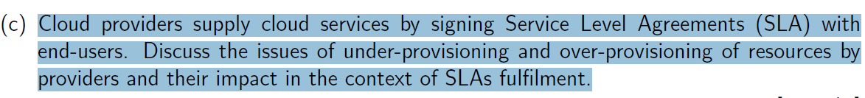

Understand under provisioning or over provisioning.

Under provisioning means as cloud provider, we tend to make less resources aviable for your customers. Wheras the over provisioning make more resources aviable that there is a waste.

If you have a service level agreement SLA with the customer in an under provisioning of resources scenario. It’s likely that your customers at some point, will need the resources that they have agree to provide. Because you may have many resources available for everyone.

This situation, lead to a service level agreement being not worth it. We call this an SLA breach. It’s a breach of contract. Because you have signed a contract with your customers, the customers want to access the resources. Unfortunately, they are not getting the resources that they have asked for. Because an under provisioning situation. And this menas you may have SLA breach.

You have more resources that you need as a cloud provider. You customer will access the resources they need. They are all happy and satisfied. However, because there are more resources than needed, you may end up wasting those resource. And there is a waste of resources in terms of CPU, memories, electricity and the light. There is always a good chance that your SLA will be fulfilled.

You certainly as a cloud provider cutting on your cost. But with the risk that may end up in an SLA breach. If an SLA is not fulfilled into an official contract, you may end up paying penalty to your consumer.

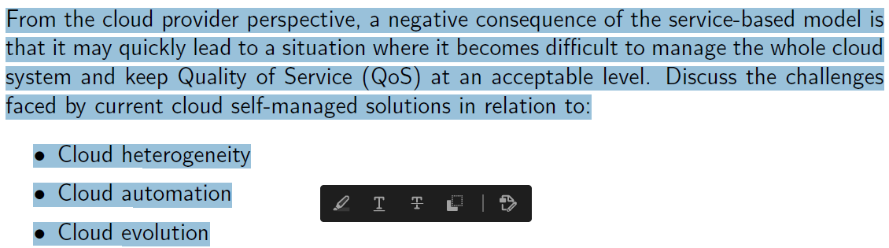

CW2 有cloud heterogeneity的写的答案

The number of challenge of cloud heterogeneity is actually seen in entire cloud stack. ……

For example, MapReduce programming model. HPC programming model like MPI. Some other basic traditional programming model. It’s heterogeneity when it becomes to the actual middleware, require you to have ……..??? Some real time constraints attched to, for example, the application.

Heterogeneity in terms of virtualization. VM comes in all sort of different flavours and images. And in terms of hardware, like the provision of the CPU, GPU, FPGA. And potentially it heterogeneity in terms of the networl. So it becomes somehow jungle.

………………………..

So these are currently being addressed by the entire research community.

When it comes to cloud automation, ……………. You will also expect that your cloud infrastructure will have which resources are being used and how many of these resources are used. You could potentially collect data about their cloud infrastructure analyse that data and potentially plan for your infrastructure to be managed differently. And therefore, what goes look what people must monitor analyse plan……

If a map?? Is putting in place. You can then expect the management of your club infrastructure to be automatic.

And that’s cloud automation is very important when it comes to provide a quality of service QoS for could customers and providers.

Cloud evolution… User is accessing in our virtual resources, those resources are certainly access elastic virtual resource……

Transparent… expect the cloud solution to be transparent to the users.

As an end user, simply want to book?? To release my elastic virtual resources. So there are sort of transparence out there, that would need to be take into account.

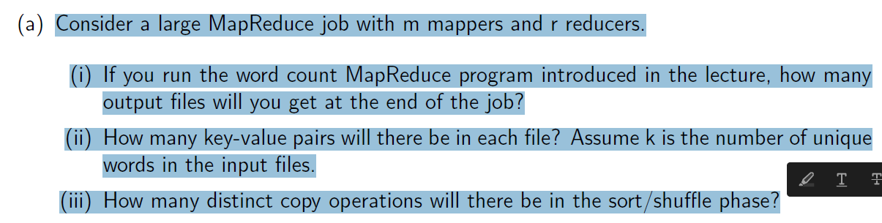

1. Reducers are collecting simultaneous set of intermediate results. Because you have R reducers, each one will provide you some set of solutions.

R

1. The intermediate output files are automatically generated by the reducers. With map reduce all this … The number of intermediate results and they actually put in files. Each reducers would have produced its own intermediate file. It’s in the field of MapReduce.

It have M mappers and R reducers, you partition the job into m workers. There are the markers and how these m workers will do some work in give the work to be finalised by this part by these reducers. And you have reducers is having reproduced on intermediate files.

………………

The answer is K over R.

1. Multiply M by R to generate the number of copy operations.

M \* R

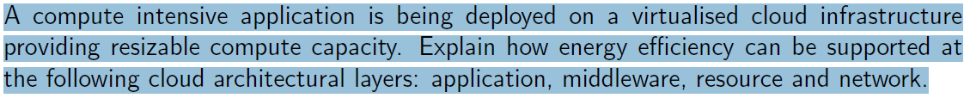

CW2也有

It looks like the evergy efficiency in each layer of the software stack. The question is can I design software and implement software that is by definition energy efficient.

Yes, keep in mind the number of instructions process, to process the less energy. It’s like I will consume the same if I have to write or design an application that is data intensive. The number of transactions inherent to the storage to reading, writing into files storge. Access to storage devices can be seen as consume energy. So I can design and implement software, taking into consideration these issues.

Ties application into thread is an excellent way to potentially address the issue with energy.

With middleware. Thinking of a service or an application to be energy aware. Then deploy my service in a … Deploy my service in a cluster X, not in cluster Y, because cluster X is more energy efficient than cluster Y. So there is decision when it comes to scheduling allocation of thoughts into cloud infrastructure.

Resources are very important, you could see the virtual resource and the physical resource. Allocate VM to an energy efficient cloud server or physical server. …Machanism that exists these days that are available for typical servers and also in your mobile phone.

For example PDF is the dynamic all page frequency system is an interesting mechanism that says, if I reduce the both page on my CPU. I am going to consume less power, but I accept that it will take me a little bit longer.

DBFS is another mechanism, that is certainly used in modern servers and also on your mobile phone.

So from the network perspective, introduce data with input and output with data is transferred over the network. There is efficient network protocol such as routing protocols. It’s likely that your network will consum less energy. Anything to do with data movement and how network protocols are designed can save energy.

Whatever you do, in application middle resource or network layer. Bear in mind that you will always need to take into cost. Save energy and you have to pay a price for performance. So this performance energy trade off is very important.

And if you deploy services are geographically closer, you wouldn’t take account into the issue with bandwidth, latency...

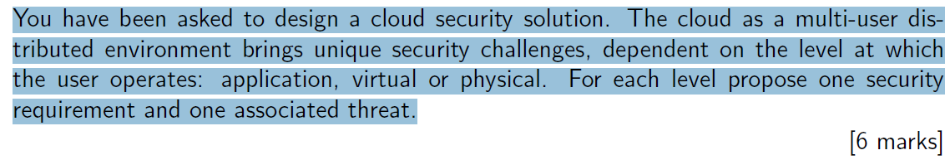

Lecture slide.

Give an example of this application running on the cloud could be a service or a set of services. The simpler requirements of this is access control. So I need to control the access to this application. For example, for the threat, think about any hijacking. Session hijacking could be a threat, because if the session associated with the application is hijacked. Then create on security issue with application. …that software interruption be the issue how exploited in order to have access to it was to create a threat on my virtual machine.

If I take a phsical server, as part of the requirement, I have a network protection so the physical server is protected through the network. What if I have an intrusion detection in my network as part of a threat. What if I have a DOS, for example an attack on my network. That’s clear a threat to my physical server. Therefore, the protection on the server is compromised. 可以从reference找到例子之类的

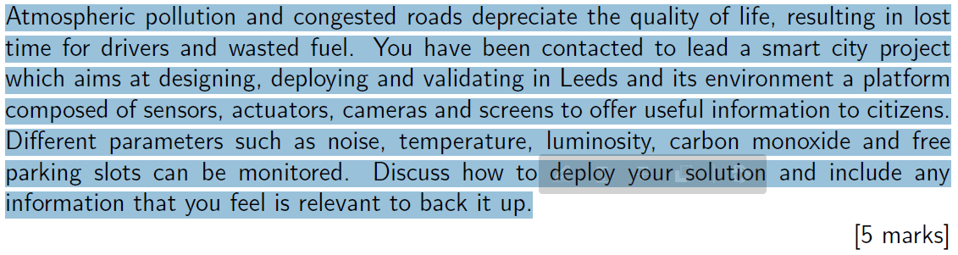

With the whole concept of sharing in the cloud. And as part of an SLA. We have to specify that in your contract and say I want to run my virtual machine on a server, and that server can be a dedicated server. I don’t want to run my VM on … belong to different entities. Because you don’t want to compromise the integrity of your VM.

IoT scenario.

Define an architecture, the architecture has to be layered, the sensor layer, network layer. Then you need to explain how data is actually sent, what are the rules? Talk about the network infrastructure.

Once the data is sent, it will get stored… What kind of technology are you going to use? Once the data is there, what are you going to do with it? What the data is processed. Some format of software, like hadoop. And you may potentially use prediction models. Because you pick up the data, you will get prediction models. Those models will tell you: according to the data that I have, the level of pollution is defined, or the level of pollution is approaching a threshold. A threshold where do we need to generate a signal or generate a message to the authority and say look, we have to do something about it.

This can be generated on screen available in the throughout the city. 有几个停车位之类的问题。

This kind of information is going to be generated all the time. Because you will keep send data to the cloud for constant processing.

In summary. Start with the architecture, then for each layer of the architecture, explain what it is, what layer actually does from data centre sesing to data transmission to data storage. Insist the technology that you would like to use. Generate usful information and use to address potential problems.